

Annual General Meeting 25th March 2025 Hearts FC
Annual Report for Year ending 31 December 2024

Scottish Culinary Team
In January 24 we hosted a night with our sponsors and the Culinary Team prepared the dinner in preparation for IKA 2024 in Stuttgart. We were delighted that Ann Budge Chairwoman of Hearts FC and Angus Robertson MSP, Cabinet Secretary for Constitution, External Affairs & Culture were in attendance.
The Team went on to win two Silver Medals which we were all hugely pleased with and a massive congratulations to all the Team members who worked so hard to achieve this.

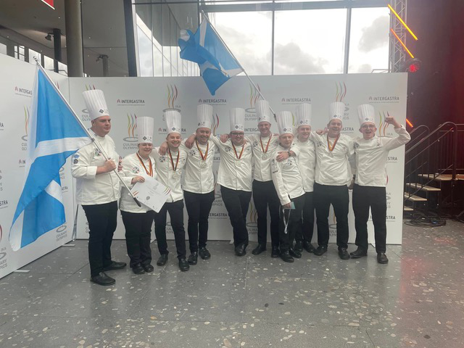
Orry Shand, Entier, Aberdeen, Team Manager
Craig Palmer, Wild Thyme, Crieff, Team Captain
Jamie MacKinnon, Seafood Restaurant, St Andrews
Fraser Cameron, The Globe Restaurant at Annandale Distillery
Craig Couper, Wild Thyme, Crieff
Andrew Clark, Entier, Aberdeen
David Millar, Jupiter Artland, Edinburgh
Simon Perkins, Bonnie Badger, Gullane
Alanna Taylor, Meldrum House Hotel, Inverurie
Rory Taylor, Entier, Aberdeen

Infusion - Our Award-Winning Magazine
We were delighted to win an award at the World Chefs Congress in Singapore that our magazine had won award for its excellence in communication to World Chef member countries
Our Magazine Infusion continues to be well received across the industry, averaging over forty pages each issue it covers a range of interesting topics the two issues per year are circulated across both the UK across the globe. Chloe Black the Editorial of Infusion is to be congratulated for all the work she has put into each issue; we look forward to the next issue due in Spring/Summer 2025
If any member of Scottish Chefs wishes to contribute to any future issue of Infusion, they should email chloe.black@scottishchefs.com

National Chef of the Year - Orry Shand

We were incredibly proud that Orry Shand won the prestigious title of National Chef of the Year at The Craft Guild of Chefs competition in London.

The National Chef of the Year competition is known for its intense challenge, with only the best, most innovative and creative chefs getting a shot at the title. Facing fierce competition from the nine other talented finalists, Orry rose to the challenge and impressed a panel of top-tier judges including Matt Abé, chef-patron at three Michelin-starred Restaurant Gordon Ramsay.

Nespresso Student Challenge
Our competition in partnership with Nespresso Professional once again saw the final take place in Edinburgh college Milton campus. Edinburgh college once again were triumphant. The students were required to show the versatility of Coffee in cooking by service of an ‘Afternoon Tea ‘The winning students from Edinburgh College were Jenny MacLeod, Eileen Ingle and Emilia Lawandowska from Edinburgh College’s Milton Campus
Each of the winning team members received an invite to Scottish Chefs 30th anniversary celebration lunch where they met Andy Cuthbert, World Chefs newly elected President, and were presented with a Nespresso M100 coffee machine for their college.
The competition aims to help find the next generation of culinary stars. They received complimentary tickets to our 30th anniversary Lunch at Murrayfield and a fantastic Nespresso machine and a pastry Master Class with David Lilley form W Hotel
2025 will be our third year of the competition and we hope to see it grow with more participation from other colleges

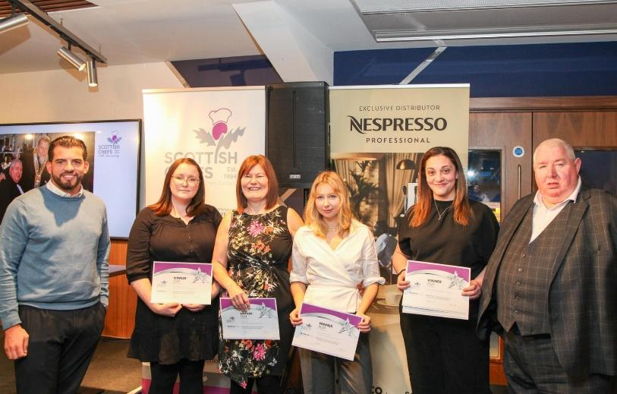

Scottish Chefs 20th Golf Day at the Carrick, Loch Lomond

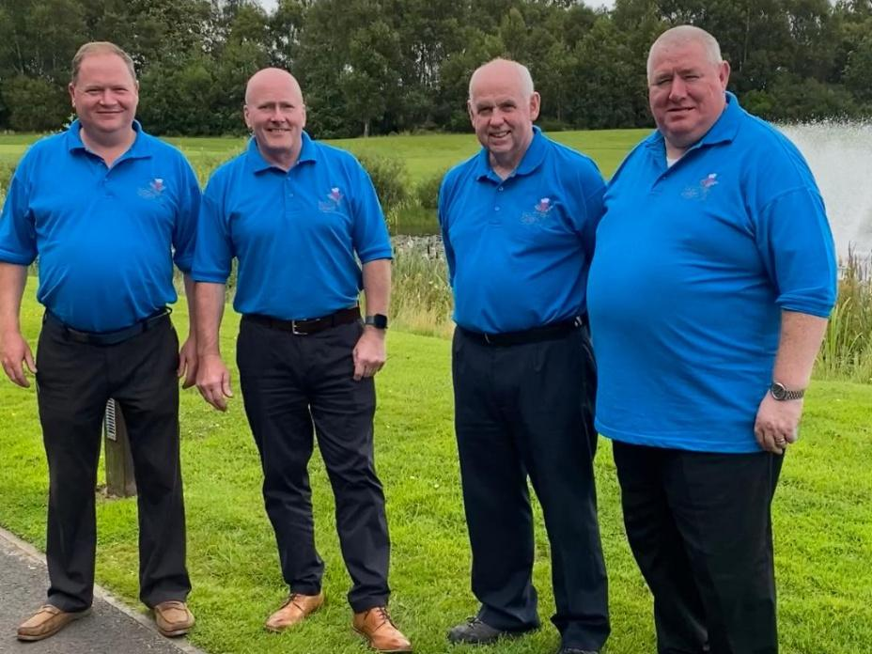
The Annual Scottish Chefs Golf Day is a highlight in the calendar for chefs and hospitality professionals in Scotland, offering networking opportunities alongside friendly competition. It is in our opinion one of the best corporate golf days in the calendar. This year’s golf day once again took place on Monday, August 5th, at the scenic Carrick Golf Course in Loch Lomond. Participants include chefs, sponsors, and members of Scottish Chefs, enjoying a great day of golf, refreshments, and a concluding barbecue once again overseen by the one and only Executive Chef James Murphy. We were once again overwhelmed by the support with auction and raffle prizes with all monies raised going towards the development of our Scottish Culinary Team. Congratulations once again to all our winners. Thanks to Aaroc Solutions Kevan Jack for his continued sponsorship. If you would like to reserve your place for next year where we are returning to the Carrick on Monday 4th August – email scottishchefs@gmail.com

Scottish Chefs Young Chefs Ambassador
In the 30th anniversary year of Scottish Chefs we launched this exciting new initiative created & facilitated to engage young, ambitious and focussed student & trainee chefs to get involved in our fantastic industry.
What will a Young Chef Ambassador do?
Represent your college or place of work in industry events
Be a spokesperson for young chefs in our industry
Communicate with your fellow students/trainees what you have learned
Create a network for the future
Build the strength of our future culinary industry
Have the opportunity to fly the flag for Scottish Chefs at global Worldchefs meetings
What are the benefits of being a Young Chef Ambassador?
Free Scottish Chefs membership
Gain knowledge and experience from working with all at Scottish Chefs
You will engage in supplier outings, field trips, events and masterclasses broadening your skills
Experience national & international competitions and get support to enter competitions yourself
Meet fellow chefs boosting both your network and professional relationships
Boost your employment opportunities by gaining experience in the industry outside the kitchen. Thank you to Selective Personnel, Dick Knives and Russums generous for their sponsorship
A special thanks to David Hunt Scottish Chefs VP and Ype van der Schaaf for their work on this project.

Worldchefs Congress , Singapore
The Bi-Annual Worldchefs Congress was held in October at the spectacular Marina Bay Sands Convention Centre , Singapore. Over 1000 delegates from all over the world attended the 3 day Congress which has some inspirational speakers and demonstrations. President Thomas Gugler completed his highly successful term as President and was succeeded by Andy Cuthbert of the Emirates Culinary Guild . The Finals of Global Chef were also held in Singapore with Italy and Norway being again among the winners of the major .
The next Congress will be held at Celtic Manor , Newport , Wales in 2026
Details of all Worldchefs events are available on www.worldchefs.org

The Home Nations
The meeting was held at the Tynecastle Stadium in Edinburgh in November and discussions took place on how the Home Nations can work more closely together for the benefit of our members and our membership WorldChefs. Talks around a charity dinner involving all countries, a 4 Nations International student competition and several other initiatives which would benefit all our members and sponsors.
The remit of the Home Nations is to work collaboratively in the joint interests of all members, chefs and the industry across the UK and Ireland. This will include competitions, training and development of our chefs in addition to providing support for Worldchefs initiatives.
The Home Nations will also share best practice to ensure that there is a consistent approach to all our activities. This will include application of culinary guidelines for national and international competitions and ensuring the adherence to Worldchefs judging criteria.
Meetings will be held Biannually with additional online meetings as required.
The Chair of the meetings will be shared with each National Association holding the chair for one year, and minutes will be recorded at each meeting.



30th Anniversary Lunch
The Scottish Chefs 30th Anniversary Lunch was a special event commemorating the founding of Scotland’s National Chefs Association, originally established in 1994 as the Federation of Chefs Scotland. The celebration lunch was held on Monday, November 18, 2024, at Scottish Gas Murrayfield Stadium in Edinburgh.
We were delighted to have as special guests Andy Cuthbert World Chefs newly elected president and MSP Mairi Gougeon Cabinet secretary for Rural Affairs, Land Reform and Islands. It was a fantastic day with a superb lunch cooked by Chef Stewart Fraser and his team from Elior and the main course cooked by our Scottish Culinary Team.
We were delighted to receive from Andy Cuthbert a special award for our E; mag Infusion, receiving World Chefs communication award presented to Chloe Black form Scottish Chefs & Karen Nisbet from Arken Creative –
We also recognised the commitment and involvement over three decades from Neil Thomson, Joe Queen & Hazel Mulbery
We also made Chef Stewart Cameron an Honorary Life Member for all is support over the years
We are all indebted to Chef Cameron in one way or another and he is truly deserving of our award of Honorary Lifetime Member of Scottish Chefs.

Future

The biggest challenge going forward of course will be increasing the profile of Scottish Chefs and having the skills and expertise to deliver, we are looking for new Board Members in particular members with fundraising experience, social media & marketing, and financial accounts and we would be delighted to hear from anyone with this expertise and extend an invitation to them to become members of the Board. Please contact Robin Austin President to discuss how you may help email robin.austin@scottishchefs.com
Over the last 30 years Scottish Chefs (Federation of Chefs Scotland) has endeavoured to represent all chefs both nationally and internationally we have hosted some of the major International Culinary Competitions across the globe including seven World Culinary Grand Prix at the SECC , Glasgow. We have sponsored ten of our colleges to compete in the USA and funded chef development both nationally and internationally. We have also supported and continue to support a range of charities including Save The Children, Worldchefs against Hunger, Robin House Children’s Hospice and have made substantial donations to the Andrew Fairlie Scholarship and the Manchester Arena Disaster Fund
It will be our mission going forward in 2024 to engage more with our members and work to increase the benefits of membership providing further opportunities for career development.

March 2025

