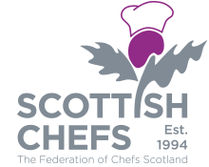

Scottish Chefs Annual Golf Day 2018

The format will be a stable ford competition with full handicap allowance anybody who doesn’t have an official handicap is limited to 18 maximum
Monday 23rd July at The Carrick golf club Loch Lomond.
Please arrive no later than 9am for your bacon roll and coffee followed by the competition brief by the PGA professional. Shotgun start is at 10.00am
The cost will be £60.00 for members and Fab 50 members and £75.00 for non-members.
Your booking will not be confirmed until full payment has been received.
Scottish Chefs will invoice you directly for payment.
Enquiries and application forms are to be sent to scottishchefs@gmail.com

